# M6. Routing Algorithms

Explain Link-state (Dijkstra’s), or Distance vector. Demonstrate Dijkstra’s (or distance vector). Explain how the two algorithms relate to RIP and BGP.

Link-state and distance vector is expression used to describe routing protocols, which is used to forward packages between network.

Routing protocols are used to find the best route in a network.

## Link-state vs distance vector

If all routers used the distance vector the route A – B would always be chosen since it only has one link.

The Link-state vector would choose the route A-C-D-B because the connections between them is a lot faster than A – B and therefore would the indirect link between A – B through C and D be a lot faster.

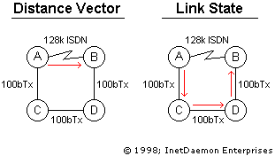

## Relation to RIP and BGP

**RIP (Routing Information Protocol)** is a dynamic distance vector routing protocol. RIP calculates the best route based on “jump count” with a maximum of 15 “jumps” to prevent looping.

**BGP (Border Gateway Protocol)** provides each autonomous system the means to:

1. Obtain subnet reachability information from neighboring autonomous systems.
2. Propagate the reachability information to all routers internal to the autonomous system.
3. Determine “good” routes to subnets based on the reachability information on autonomous system policy.

Most importantly, does BGP allow each subnet to advertise its existence to the rest of the internet.

Very much alike the link-state where this would give the ability to find the shortest way.